DSC 450: Database Processing for Large-Scale Analytics

Assignment Module 4 - Charles Hanlon

Part 1

- Using the extended Zoo database (ZooDatabase_extended.sql), write the following queries in SQL:

- Find all the rare animals and sort the query output by feeding time (from small to large)
SELECT * FROM Animal
WHERE acategory = 'rare'
ORDER BY TimeToFeed ASC;

- Find the animal names and categories for animals related to a bear (hint: use the LIKE operator)
SELECT AName, ACategory FROM Animal
WHERE AName LIKE '%bear';

- Find the names of the animals that are related to the bear and are common
SELECT AName, ACategory FROM Animal
WHERE AName LIKE '%bear' AND ACategory = 'common';

- Find the names of the animals that are not related to a tiger
SELECT AName FROM Animal
WHERE AName NOT LIKE '%tiger';

- List the animals (animal names) and the ID of the zoo keeper assigned to them.
SELECT animal.AName, keeper.ZooKeepID
FROM Animal animal, Handles keeper
WHERE animal.AID = keeper.AnimalID;

- Now repeat the previous query and make sure that the animals without an assigned handler also appear in the answer.
SELECT animal.AName, keeper.ZooKeepID
FROM Animal animal
LEFT JOIN Handles keeper ON animal.AID = keeper.AnimalID;

- Report, for every zoo keeper name, the average number of hours they spend feeding an animal in their care. Groupby
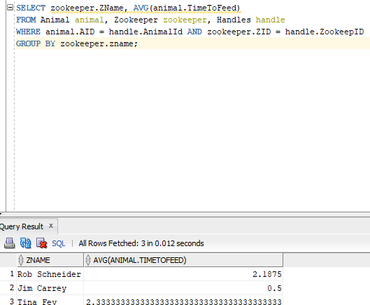

- Report every handling assignment (as a list of assignment date, zoo keeper name and animal name). Sort the result of the query by the assignment date in an ascending order.
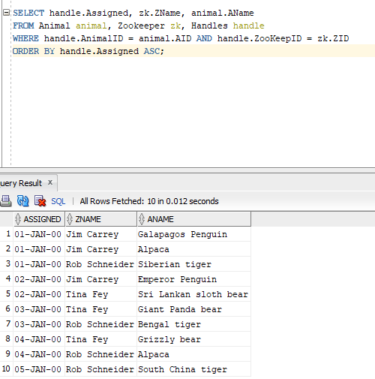

- Write the following queries using python (i.e., by reading data from animal.txt, without using a database or SQL language). The idea is to replicate, in python, what a database does when the query executes.

- Find the animal names and categories for animals not related to a tiger
import sqlite3

def fakeSql():
word = 'tiger'
f = open("animal.txt", "r") # open file

conn = sqlite3.connect('assignment41.db') # open db conection
cursor = conn.cursor()

allData = f.read()
allDataLines = allData.split("\n")
allDataLines = allDataLines[:-1]

for data in allDataLines:
if word not in data:
tmp = data.split(', ')
print(tmp[1], tmp[2])

f.close()
conn.close()

fakeSql()

- Find the names of the animals that are related to a bear and are not common
import sqlite3

def fakeSql():
word = 'bear'
f = open("animal.txt", "r") # open file

conn = sqlite3.connect('assignment41.db') # open db conection
cursor = conn.cursor()

allData = f.read()
allDataLines = allData.split("\n")
allDataLines = allDataLines[:-1]

for data in allDataLines:
if word in data and 'common' not in data:
tmp = data.split(', ')
print(tmp[1], tmp[2])

f.close()
conn.close()

fakeSql()

Part 2

- You are given a following schema in 1NF:
(First, Last, Address, Job, Salary, Assistant) and the following set of functional dependencies:

First, Last → Address
Job → Salary, Assistant

Decompose the schema to make sure it is in Third Normal Form (3NF).

(First, Last, Address, JobType)

(Job, Salary, Assistant)

- Write the necessary SQL DDL statements (CREATE TABLE) to define these the tables you created

- Write a python script that is going to create your tables and populate them with data automatically from data_module4_part2.txt (file attached). You do not have to use executemany, your python code can load data row-by-row. Make sure that you are inserting a proper NULL into the database. HINT: You can use INSERT OR IGNORE statement (instead of a regular INSERT statement) in SQLite to skip over duplicate primary key inserts without throwing an error.

For example:
cursor.execute("INSERT OR IGNORE INTO Animal VALUES(?,?,?,?)", [11, 'Llama', None, 3.5]);
would automatically ignore the insert if animal with ID 11 already exists in the database and insert a NULL into the third column. If you use ‘NULL’ value instead, animal category would be set to the 4-character string ‘NULL’

- Verify that your NULLS are loaded correctly, by finding all jobs with no salary specified using Salary IS NULL condition. CODE BELOW ANSWERS ALL
import sqlite3

def assignmentPartTwo():

createTablePerson = """
CREATE TABLE Person
(
FirstName VARCHAR2(30) NOT NULL,
LastName VARCHAR2(30) NOT NULL,
Adress VARCHAR2(100),
JobType VARCHAR2(30),

CONSTRAINT Person_PK
PRIMARY KEY(FirstName, LastName)
);
"""
createTableJob = """
CREATE TABLE Jobs
(
Job VARCHAR2(30),
Salary NUMBER(7, 0),
Assistant VARCHAR2(30),

CONSTRAINT Jobs_PK
PRIMARY KEY(Job),

CONSTRAINT Jobs_FK
FOREIGN KEY(Job)
REFERENCES Person(JobType)
);
"""
dropTablePerson = "DROP TABLE IF EXISTS Person"
dropTableJobs = "DROP TABLE IF EXISTS Jobs"

#function begin

f = open("data_module4_part2.txt", "r") # open file

conn = sqlite3.connect('assignment4b.db') # open db conection
cursor = conn.cursor()

#table setup
cursor.execute(dropTablePerson)
cursor.execute(dropTableJobs)
cursor.execute(createTablePerson)
cursor.execute(createTableJob)

allData = f.read()
allDataLines = allData.split("\n")
allDataLines = allDataLines[:-1]

for data in allDataLines:
tmp = data.split(', ')
print(tmp)
cursor.execute("INSERT OR IGNORE INTO Person VALUES(?,?,?,?)", tmp[:4])
tmp = [None if value == 'NULL' else value for value in tmp]
cursor.execute("INSERT OR IGNORE INTO Jobs VALUES(?,?,?)", tmp[3:])

query1 = cursor.execute("SELECT * FROM Person;").fetchall()
query2 = cursor.execute("SELECT * FROM Jobs;").fetchall()
query3 = cursor.execute("SELECT Job FROM Jobs WHERE Salary IS NULL").fetchall()
print('Testing Person')
print(query1)
print('--------------------------------------------------------------------')
print('Testing Jobs')
print(query2)
print('--------------------------------------------------------------------')
print('Testing for question D')
print(query3)
print('--------------------------------------------------------------------')

f.close()
conn.close()

assignmentPartTwo()
